
ABOUT MY FEDERAL SERVICE FOR MY COUNTRY (return to homepage)
My sworn statement to the FBI that everything on this website is true
THE ATTACKS
"When bad men combine, the good must associate;
else they will fall, one by one, an unpitied sacrifice in a contemptible struggle."
Edmund Burke, 1770
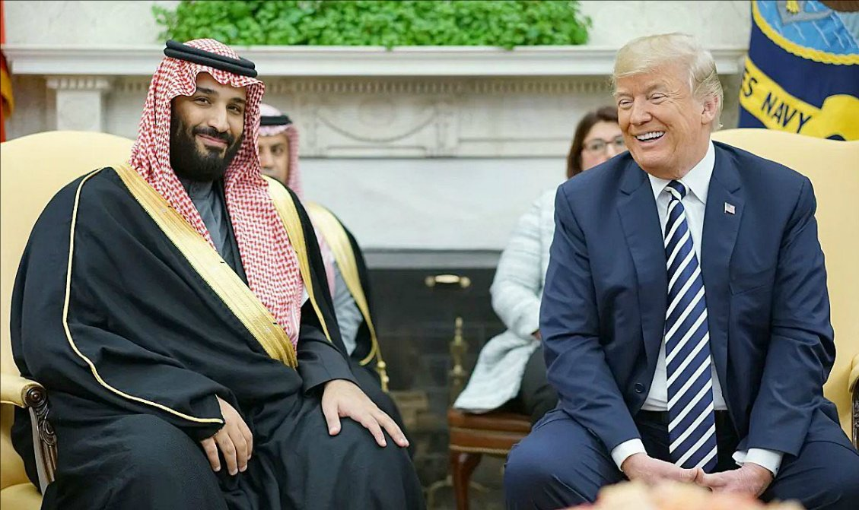
Saudi Crown Prince “MBS” (Mohammed bin Salman Al Saud) meeting in The Oval Office on March 20, 2018, with convicted felon Donald Trump. MBS ordered the grotesque murder of Washington Post reporter Jamil Khashoggi, then tried to cover it up with a body double.  Why? Because Khashoggi wrote something on piece of paper (Washington Post) that MBS didn’t like. What Khashoggi wrote is protected under the First Amendment of the United States Constitution (freedom of the press).  MBS’s royal family owns Saudi Aramco (SABIC). SABIC and the wealthiest petrochemical companies in the world are using my US Patent 8,391,552 disguised as a non-patented technology – for free.  US taxpayers got no recognition and were cheated out of the royalties due to the US Treasury. | Convicted felon Donald Trump. Found guilty on all 34 counts of falsifying documents to hide that he paid off porn star, Stormy Daniels, so he could steal a US Presidential election.  He faces three more trials for his felony crimes, including violation of the RICO Act and inciting a mob to attack the Capitol on January 6 in a violent conspiracy to overturn a valid Presidential election  In 2018, the Trump Admin fabricated false charges against me and used violent felony crimes to force me to flee from federal service.  A SWAT team raided my house on January 18, 2019, without cause. My house was then stolen from me under color-of-law in retaliation for my work for civil rights in Pittsburgh.
Independent experts found my US Patent 8,391,552 to be “a huge breakthrough”
and “something the petrochemical industry had sought for 50 years.”
The photo above shows MBS meeting with Trump in the Oval Office on March 20, 2018. This was sixty-one (61) days after senior federal officials of the Trump Administration escalated their felony attacks on me at the USDOE National Energy Technology Laboratory (NETL). The attacks were led by:
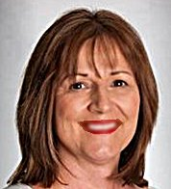 | NETL Director Dr. Grace Bochenek, former Secretary of Energy, former Director of the US Army Chemical and Biological Combat Capabilities Development Command (DEVCOM).
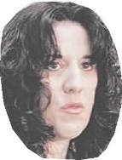 | NETL Chief Counsel Susan E. Malie, former City Solicitor of Pittsburgh, Director of the City of Pittsburgh Law Department, and Lead Counsel for the Pittsburgh Police.
 | NETL Law Director, former Navy JAG Commander, General Counsel of 60,000 combat-ready troops, corps leader for 800 attorneys, Mark Hunzeker.
Names of the other attackers are listed further below on this page.

THE ATTACKS
This page describes the attacks on me, a federal employee, since I played an important role in causing British Petroleum to be fined $20.8 billion dollars under the Clean Water Act for crude oil BP wrecklessly released into the Gulf of Mexico.
It is the largest single fine of a single entity in US history.
The fine was ordered on October 5, 2015, by the Honorable US District Court Judge Carl J. Barbier for the Eastern District of Louisiana.
Judge Barbier is presiding over the ongoing MultiDistrict Litigation 2179.
It is the largest litigation in US history.
Senior federal officials of the first Trump Admin fabricated false charges against me and violently attacked me at the USDOE National Energy Technology Laboratory (NETL). They forced me to flee the NETL on July 9, 2018, to protect my life. On January 18, 2019, Republican Magistrate Ronald Arnoni had a SWAT team raid my home without cause. That night I fled into Amish country Ohio to escape. The Trump Admin got rid of me so they could disguise my US Patent 8,391,552 as a non-patented technology. Then they gave the technology of my 8,391,552 to Saudi Aramco (SABIC) and the world’s wealthiest petrochemical companies -- for free.
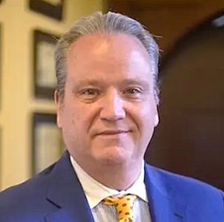  Trump Attorney  David C. Devine | NEW: I got a call from Trump Attorney David C. Devine informing me that Trump’s lead attorney Michael van der Veen would like to “consult with, confer, and speak with me” and telling me to  “have a safe evening Mr. Shaffer”  Click here to listen to the voicemail from  Trump Attorney Devine | Trump’s lead Attorney Michael van der Veen speaking to the US Senate during the first impeachment trial of Donald Trump
Given that Trump’s attorneys David C. Devine and Micheal van der Veen likely know that I was attacked at the NETL by Trump’s senior-most federal employees (see the list below), his telling me to “have a safe evening Mr. Shaffer” does not make me feel safe at all. It makes me feel like he’s trying to intimidate me – as in witness intimidation.
I will not be intimidated.
My sworn statement to the FBI that everything on this website is true
MOTIVES FOR THE ATTACKS
- MOTIVE 1: Retaliation for my important role in causing British Petroleum to be fined $20.8 billion dollars under the Clean Water Act
- MOTIVE 2: Espionage with my US Patent 8,391,552. Patent 8,391,552 was developed using nuclear weapons technologies. It can be used to improve nuclear weapons. Because Trump gave the technology of 8,391,552 to countries whose interests are hostile to the interests of our country, he put our country in danger. Under US Code 18 Section 794, that is a Capital Offense.
NEW: A detailed description of the attacks at the NETL.
- MOTIVE 3: Retaliation for my work for social justice and civil rights at the USDOE NETL and with Thomas Merton Center in Pittsburgh.
- MOTIVE 4: The royalties of my US Patent 8,391,552. Allegheny County common pleas Judge Hugh F. McGough, Allegheny County Solicitor Luke C. Kelly and Dr. Nancy Joyce Shaffer used perjury and felony crimes to try to gain control of the royalties generated by 8,391,552. Their most heinous attacks were in the form of antisemitic, homophobic hate crimes. Click here to see my report to the FBI describing their hate crimes.
- MOTIVE 5: The DOE National Nuclear Security Administration (NNSA) conspired to let those listed above permanently silence me to hide the NNSA’s illegal proliferation of nuclear weapons into a non-nuclear country, Pakistan. We gave nuclear weapons technologies (the AVLIS process from Los Alamos) to the Prime Minister of Pakistan Muhammed Nawaz Sharif, A.Q. Khan, and the Pakistan Army. At that time, the Prime Minister of Pakistan was on the payroll of Osama bin Laden.
I am an eyewitness to the proliferation of nuclear weapons into Pakistan.
I have official USDOE documents to verify this.
Click here to see the entire story, including official DOE documents.
A.Q. Khan then sold the nuclear weapons technologies from Los Alamos to several communist and Islamic states. Soon thereafter, Iran began producing highly enriched uranium for nuclear weapons using the AVLIS process at Iran’s Lashkar Ab’ad laboratory (and who really knows where else?)
Click here for info about my Atomic Vapor Laser. It was built by the same engineers from Los Alamos who proliferated nuclear weapons into Pakistan.
Click here for my report to the NNSA and FBI
on the proliferation of nuclear weapons into Pakistan.
  Prime Minister of Pakistan  Muhammed Nawaz Sharif. Leader of the Pakistan Muslim Party. On May 3, 2024, he was again elected as the Prime Minister of Pakistan. | 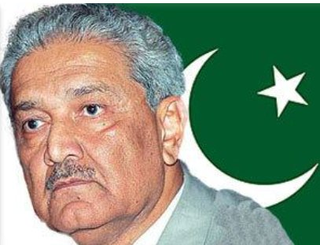  Dr Abdul Qadeer “A.Q.” Khan, Father of Pakistan’s nuclear weapons program. Infamous proliferator of nuclear weapons. Died in Islamabad Pakistan on October 10, 2021. | 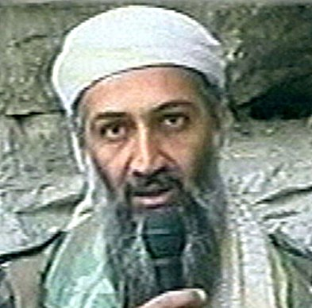  After 911, Pakistan hid Osama bin Laden for years. Our special forces had to risk their lives to extract him from his luxury compound in Abbotabad.
THE $20.8 BILLION DOLLAR FINE
THAT NEARLY COST ME MY LIFE
What is $20.8 billion dollars? I had no idea. I had to look it up myself.
If you spent one million dollars every day, it would take you 57 years to spend $20.8 billion dollars. If you stacked $100 bills, to reach $20.8 billion, the stack would be 14 miles high. The highest altitude flown by commercial airlines is 7 miles.
The stack would weigh more than 200 tons.
Below is an illustration of Benjamin Franklin standing beside
$1 billion dollars in $100 dollar bills. He was 5’9” tall. The stack weighs 10 tons.
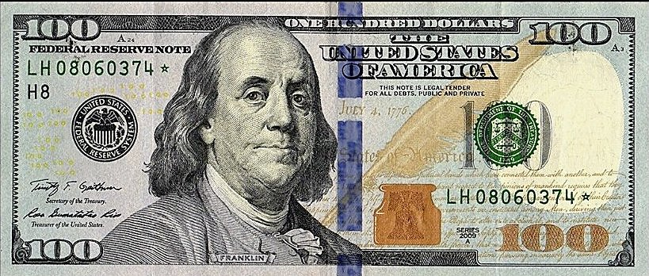
This is Benjamin Franklin standing beside $20.8 billion dollars in $100 dollar bills.
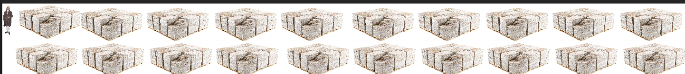
This is how much money I caused British Petroleum to be fined.
MY LIFE BEFORE THE $20.8 BILLION FINE
Before October 5, 2015, my performance with the USDOE was always outstanding
Click here to see my awards for “exemplary service” for our nation.
I am one of the founders of the United States Department of Energy’s
National Energy Technology Laboratory.
For thirty years I’d been trusted with state secrets about the proliferation, proposed use, and actual use of nuclear weapons.
I used nuclear weapons technologies in my research.
In 2013 through 2015, I was cleared by the FBI to do large-scale experiments with JP5 jet fuel inside Naval Weapons Station Earle with an engineer from Russian controlled Estonia.
I had never been arrested for anything more serious than a traffic violation.
The 535 federal employees of the NETL had been my only community for 32 years. I had a family I loved. I had a secure federal job I loved.
I had a unique Zero Energy Design (ZED) house. I had retirement savings.
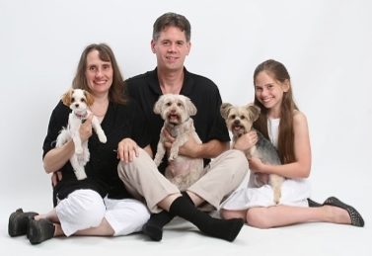 | 
MY LIFE AFTER THE $20.8 BILLION FINE
There have been false, defamatory, inflammatory records created about me at the local, county, state, and federal levels. The lies were fabricated by lawyers, police, judges, senior federal employees and federal security officers of the Trump Admin.
Their heinous inflammatory lies are designed to dissuade anyone from helping me -- and to incite everyone to harm me. Their lies have caused me to be attacked and harmed, many times. There have been many attempts to cause my death.
My federal career has been destroyed. My family has been destroyed. I’ve been ostracized from the NETL, the only community I had for 32 years. Some of the attackers have taken credit for my work and patents.
Almost everything I earned in 32 years of federal service
to our country has been stolen from me under color-of-law.
The attacks were so vicious and relentless that on April 7, 2019, after 41 months of attacks, I tried to end my life to escape their attacks. I also believed it was my responsibility to end my life to protect the state secrets I’d been trusted with by the USDOE regarding nuclear weapons. I was in the ICU and hospital for five days.
One of those state secrets is our proliferation of nuclear weapons into Pakistan.
Click here for the full story supported by official USDOE documents.

When I fled into Amish country Ohio, I was staying in a small camper owned by the “chicken ladies.” My new job was mending a chicken coup.
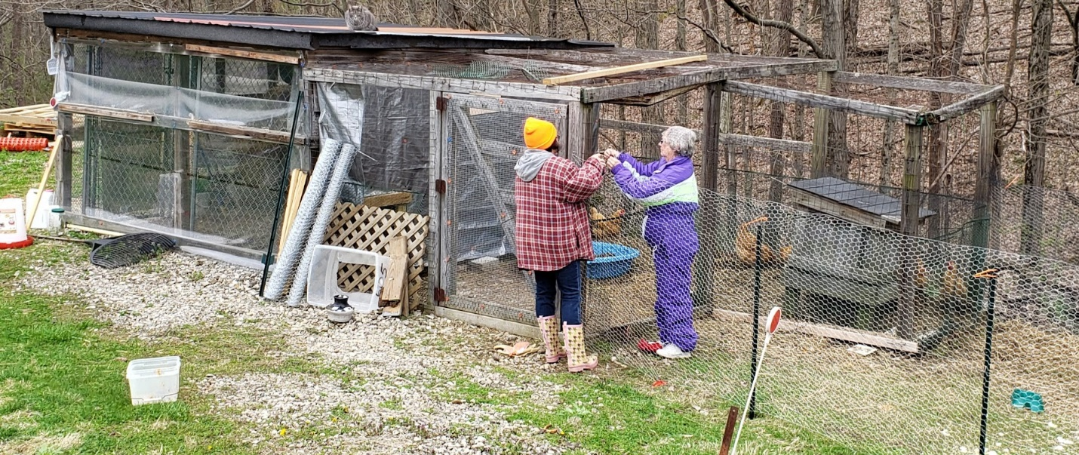
CHRONOLOGY OF THE ATTACKS
AFTER THE $20.8 BILLION DOLLAR FINE WAS ORDERED
TWENTY-FIVE (25) days after the $20.8 billion dollar fine was ordered, on October 30, 2015, I was violently attacked by Dr. Nancy J. Shaffer. She tried to slam a piece of hardwood furniture into my head while I was half-conscious because I was on a three-week course of doxycycline to treat Lyme disease. I was infected with the bacteria that causes Lyme disease while working at the OHMSETT facility inside Naval Weapons Station Earle in Leonardo NJ. NWS Earle is one-hundred miles due south of Lyme CT.  NINETY-FIVE (95) days after the $20.8 billion dollar fine was ordered, on January 8, 2016, false records were fabricated about me giving the impression that I assaulted my wife and a little girl with autism using a weapon that was hidden from public view. I was not arrested or charged with anything because I’d done nothing wrong. |  | 
Thirty years ago, a PhD Nuclear Engineer, Dr. Everett Ramer, convinced me to live a life of non-violent pacifism. I’ve been a Christian Buddhist pacifist since then. This is my weapon of choice: Je suis Charlie!

On January 8, 2016, a Violent Lying Criminal (VLC) named Magistrate Ronald Arnoni ordered three Bethel Park Police Officers to raid my home without cause, throw me out, then search my entire house. Then they fabricated despicable false records about me.
I do not assault anyone -- let alone helpless little autistic girls. Instead, I got her a puppy. I got her a “cool” ZED house to help her make friends. I got her into one of the best school systems in Pennsylvania. This is the little girl that those cowardly Violent Lying Criminals created records saying I assaulted:
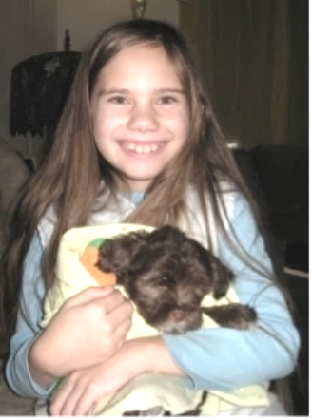 | 
Docket FD-16-000031 in Allegheny County Court Records is a color-of-law attack:
Docket FD-16-000031 was created on January 8, 2016 -- two months after the $20.8 billion fine. FD-16-000031 is nothing but a color-of-law attack on me in retaliation for causing the $20.8 billion fine and in retaliation for my civil rights work. It is nothing but false, defamatory, inflammatory lies about me. After eight years and seven months, FD-16-000031 is still open and lies are still being added to it. Here’s a link to Allegheny County Court Records where you can see their despicable lies about me:
https://dcr.alleghenycounty.us/Civil/LoginSearch.aspx
ONE HUNDRED AND TWENTY-SIX (126) days after the $20.8 billion dollar fine, on February 8, 2016, the VLC Magistrate Arnoni promoted all three VLC Officers who threw me out of my home and fabricated false records about me -- to VLC Sergeants.
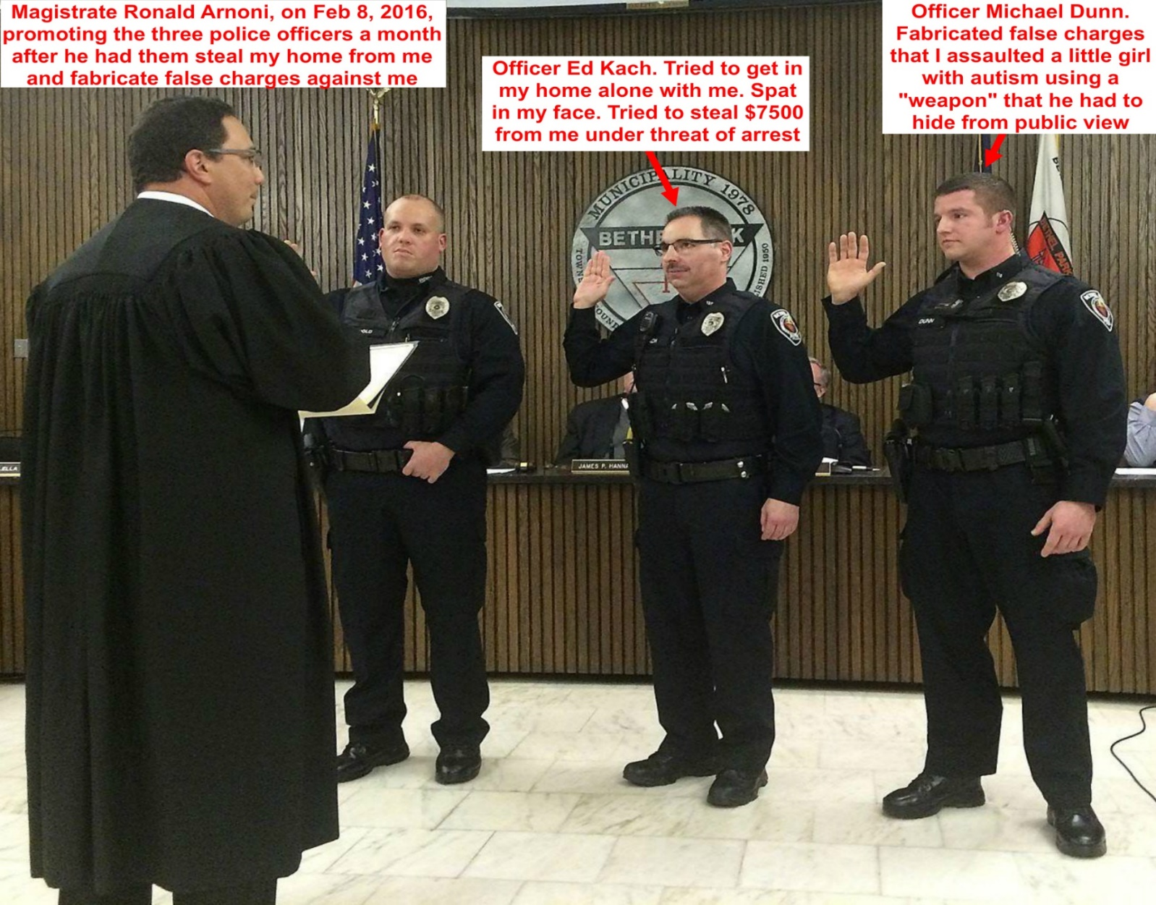
My sworn statement to the FBI that everything on this website is true
ONE HUNDRED AND FORTY-TWO (142) days after the $20.8 billion dollar fine was ordered, my father’s funeral was desecrated in the Episcopal Church where he was a Priest. My father was dying in January and February of 2016. I could not spend time with him because I had to stay in Pittsburgh to defend myself against the fabricated false charges.
My father, Reverend Dr. Dallas B. Shaffer, did not accept money for his services. He was a hospital chaplain. He was an honorable US Army veteran who served on foreign soil. Notice the 13 tri-fold flag by his casket. To learn more about the desecration of my father’s funeral and to watch an example of the tri-fold flag ceremony at the funeral of an honorable US Army veteran, click here or on the images below:
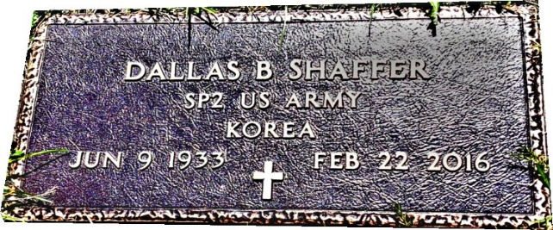
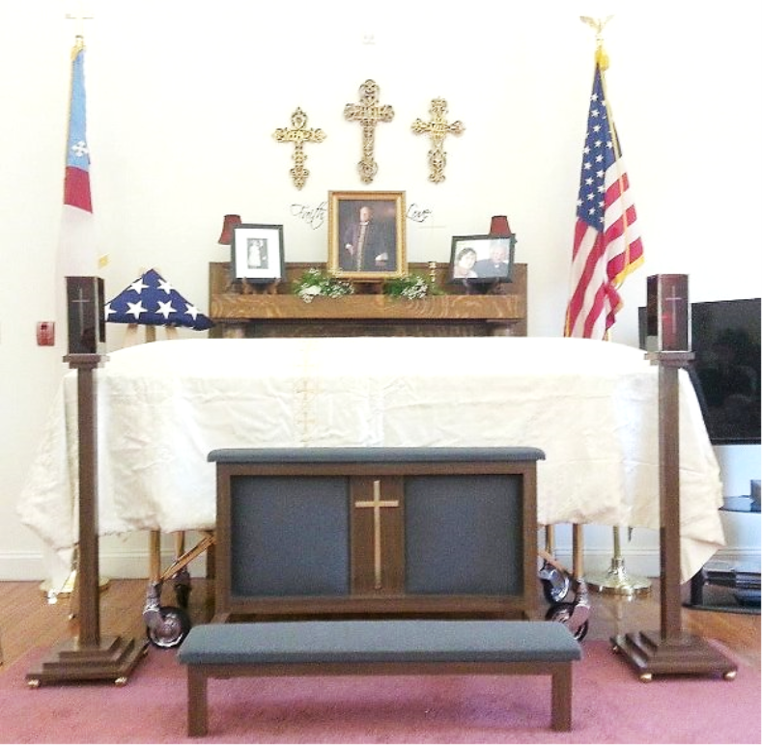
On February 22, 2014, as per his wishes, my father drew his last breath
with two federal employees by his sides.
My brother was holding his left hand. I was holding his right hand.
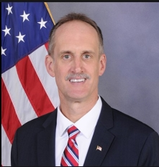  Dr. Douglas N. Shaffer, MD  US FDA Associate Director,  Office of Global Policy & Strategy | 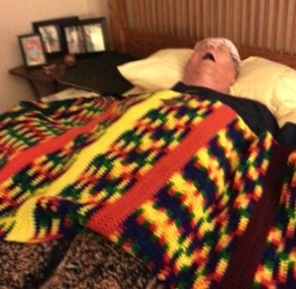  Reverend Dr. Dallas B. Shaffer.  His last breath, February 22, 2016. | 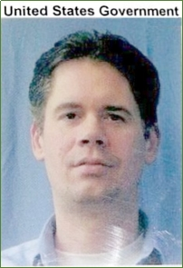  Senior Research Engineer  US Department of Energy

My sworn statement to the FBI that everything on this website is true
PART 2: ATTACKS IN THE COMMISSION OF ESPIONAGE WITH MY US PATENT 8,391,552
The technology I invented in 2008 and protected with US Patent 8,391,552 in 2013 was one of the tools I used when I was on the lead team responding to the Deepwater Horizon oil leak crisis.
Independent experts reviewed the technology of 8,391,552 and found it to be
“something the petrochemical industry had sought for 50 years.”
NEW: A detailed report describing the twenty years of engineering time, millions of US taxpayer dollars, and the nuclear weapons technologies that went into the development of US Patent 8,391,552.
TWO VIOLENT LYING CRIMINALS WHO FABRICATED FALSE CHARGES AGAINST ME AND VIOLENTLY ENDANGERED MY LIFE
TO TRY TO GAIN CONTROL OF MY US PATENT 8,391,522
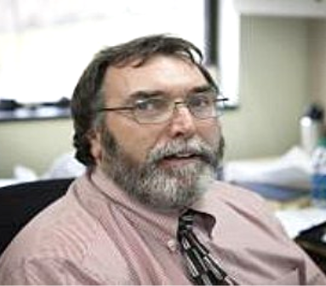  USDOE federal employee, the VLC Dr. Ronald Wayne Breault. | 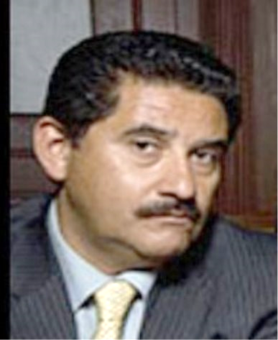  Allegheny County Solicitor Luke C. Kelly.
My sworn statement to the FBI that everything on this website is true
CHRONOLOGY OF THE ATTACKS BY THE TRUMP ADMIN
IN THE COMMISSION OF ESPIONAGE WITH US PATENT 8,391,552
The espionage with Patent 8,391,552 began in February of 2017 immediately after Trump took Office. It was launched in earnest in 2018 at the Eighth World Conference on Particle Technology (8WCPT). The World Conference on Particle Technology is held every four years. It is attended by more than five hundred scientists and engineers from around the world. Below is a list of the locations of the World Congress on Particle Technology:
1WCPT | Beijing, China | 1990
2WCPT | Kyoto, Japan | 1994
3WCPT | Brightton, United Kingdom | 1998
4WCPT | Sydney, Australia | 2002
5WCPT | Orlando, United States | 2006
6WCPT | Nürnberg, Germany | 2010
7WCPT | Beijing, China | 2014
8WCPT | Orlando, United States | 2018
9WCPT | Madrid, Spain | 2022
10WCPT | Osaka, Japan | 2026
Below is the schedule for authors to submit, present and publish papers in the Proceedings of the 8WCPT. The attacks at the NETL in 2018 correspond exactly with the dates of the 8WCPT in the table below.
September 2017 | Papers submitted for acceptance for the 8WCPT
January 2018 | Authors notified if their paper is accepted
January 2018 | Final Program for the 8WCPT is made public
April 1, 2018 | Drafts of full papers submitted
April 23-28, 2018 | Papers presented at the 8WCPT
June 2018 | Final full papers submitted for publication
August 2018 | Proceedings posted online

NINETY-EIGHT (98) DAYS BEFORE THE 8WCPT, on January 16, 2018, when the Final Program for the 8WCPT was made public, NETL COO Linda S. Kimberling, NETL Site Security Officer Allen K. Lichvar, VLC Breault, and other senior Trump officials falsely accused me of putting the entire NETL at risk by leaving a window in my office open by 1.5”. I’d had that window opened like that for ten years with no problems.
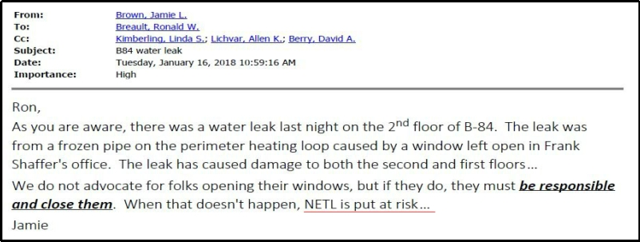
The fabrication of false charges and violent attacks were led by the NETL Engineer Dr. Ronald Wayne Breault. He, Justin Weber, Tingwen Li, William Rogers, Balaji Gopalan, John Higham (and others to be named soon) would present and publish papers at the 8WCPT and for the next five years describing my work and the technology of US Patent 8,391,552 – but with their name replacing mine.
They fabricated the lied that US Patent 8,391,552 was a new non-patented “open source” technology they invented.
NETL Engineer Dr. Ronald Wayne Breault, a federal employee, published fraudulent presentations and papers to cover-up  his violent espionage with Patent 8,391,552. | 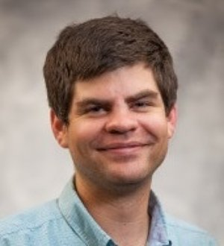  NETL Engineer Justin Weber, a federal employee, published fraudulent presentations and papers to cover-up  his espionage with Patent 8,391,552.
FRADULENT PUBLICATIONS BY THE PETROCHEMICAL INDUSTRY AND THE NETL TO COVER-UP ESPIONAGE BY THE TRUMP ADMIN WITH 8,391,552
Below is a partial list of the fraudulent publications by the petrochemical industry and the world’s largest fossil fuel research laboratory, the USDOE NETL, to try to cover-up their violent espionage with my US Patent 8,391,552. The purpose of their fraudulent papers and presentations was to publish lies that US Patent 8,391,552 is not unique – that there are many other technologies that produce the same product as 8,391,552. That is a prima facie lie.
It is an insult to USDOE Patent Attorneys James Potts and John T. Lucas.
It is an insult to the hard work of the Patent Examiners.
It is an insult to the US Patent & Trademark Office.
Examples of their fraudulent publications:
- Particle Tracking Velocimetry Measurements for CFD-DEM Validation, by Casey Q. LaMarche³, P. Liu³, W. Fullmer, Eighth World Congress on Particle Technology, April 2018
- Heterogenous Reactor Development , an NETL publication by Ronald W. Breault and Justin Weber¹, 2019
- Tracker, an Opensource Particle Tracking Velocimetry (PTV) applied to Multiphase Flow Reactors , by Justin Weber¹, Michael Bobek¹, Steven Rowan¹, Jingsi Yang¹and Ronald Breault¹, Proceedings of the American-Japanese-Korean Societies of Mechanical Engineering, Joint Fluids Engineering Conference, San Francisco, July 28 - August 1, 2019
- Comparison of velocimetry methods for horizontal air jets in a semicircular fluidized bed of Geldart Group D particles , by William D. Fullmer¹, Jonathan E. Higham⁴, Casey Q. LaMarche³, Allan Issangya³, Ray Cocco³, Christine M. Hrenya², Journal of Powder Technology, Volume 359, Pages 323-330, January 1, 2020
- Critical analysis of velocimetry methods for particulate flows from synthetic data, by Justin Weber¹, Jonathan E. Higham⁴, Jordan Musser¹, William D. Fullmer¹, Chemical Engineering Journal, Volume 415, July 1, 2021
- USDOE National Energy Technology Laboratory
- University of Colorado at Boulder
- Particulate Solids Research Inc, PSRI.org
- University of Liverpool, United Kingdom
I will post more examples of their fraudulent publications soon. Here is the lie they put forth in their fraudulent publications to cover-up their violent espionage with 8,391,552:
“There have been many algorithms developed to track objects in high-speed videos including shake-the-box [1], HsPIV [2], Voroni method applied to granular flows [3, 4], and various predictor methods [5] as well as a collection of programs and tools such as PTVlab [6], PTVResearch [7], OpenPTV [8], and TracTrac [9].”

The statement above is a lie:
- HsPIV is my patent 8,391,552
- Shake-the-box and Voroni methods do not produce the same product as 8,391,552
- PTVlab, PTVResearch, OpenPTV and TracTrac were all developed after I published the algorithm of US Patent 8,391,552 in 2010.
THREE (3) DAYS BEFORE THE 8WCPT, on April 20, 2018, VLC Breault issued a fraudulent disciplinary action against me to suspend me from federal service. He alleged that I committed the “very serious” crime of opening a window in my office on a hot day and disobeying his orders to close it. Click here or on the image to see the entire fraudulent disciplinary action.
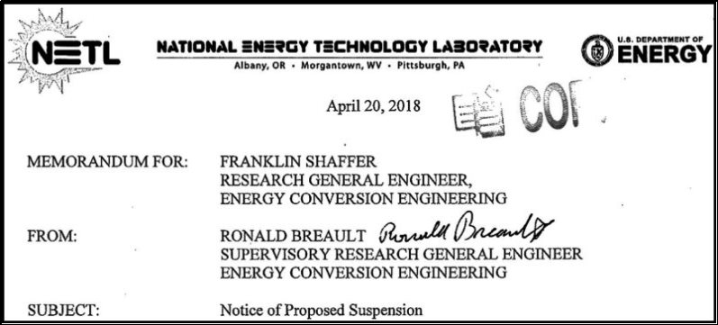
AFGE President Francis Wright came to work to try to defend me. To defend me, Sister Wright had to leave her husband who was dying with stage IV cancer. Click here to see Sister Fran’s response.
While I was being attacked at the NETL in 2018, my best friend of 20 years and the Best Man in my wedding, NETL Engineer and former NETL Chief Information Officer, Otis Mills Jr, tried to defend me.
Later his skull was crushed with a police baton. The last time I spoke with Otis was on the phone. I did not recognize his voice. He was working with a speech therapist to learn to speak again.
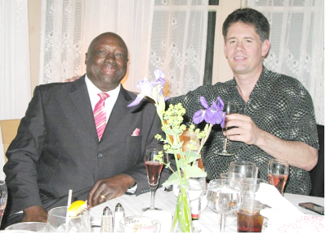  With my Best Man Otis Mills Jr at my wedding announcement party in Pittsburgh. Otis is an honorable US Army Veteran. His son Micheal was an enlisted Officer in the US Army. | 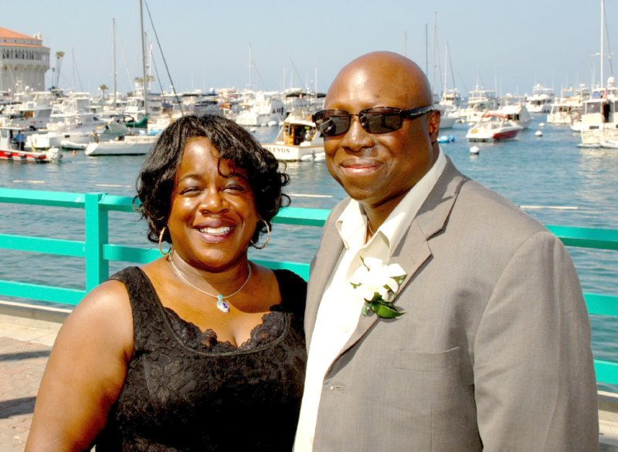  Otis with his beautiful wife of 40 years, Gayle, at my wedding on Catalina Island. They have three children, “The Three M’s”,” Marlin, Michael and Monique, and a growing number of grandchildren.
THE TRUMP ADMIN TRYING TO ILLEGALLY FIRE ME AFTER THE 8WCPT TO HIDE THEIR ESPIONAGE
ELEVEN (11) DAYS AFTER THE 8WCPT, Trump’s criminals NETL Chief Counsel Susan E. Malie and NETL Law Department Director Mark Hunzeker begin their effort to drive me from federal service by illegally firing me. Not only would I lose my federal job, but I would lose the benefits I earned in 32 years of federal service.
Below is an email from Chief Counsel Malie and Law Director Hunzeker. They are having NETL Site Security Officer Lichvar search for evidence of days I was not at the NETL. I was not at the NETL on some of those days because if I showed up for work, they would attack me and put my life in danger.
The dates April 4-13, 2018, were just before the 8WCPT opened on April 23, 2018.
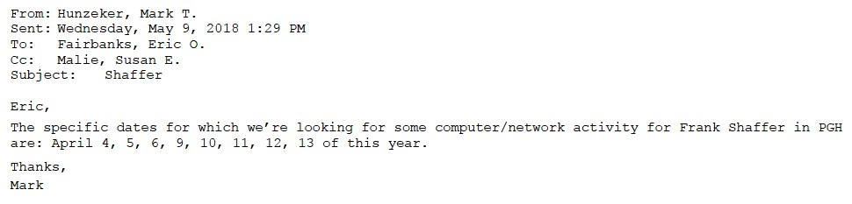
Three years later, after I’d fled into Amish country Ohio to escape their attacks, armed FBI agents wearing body armor, including FBI Agent Lisa Brown, showed up at my low-rent apartment in Newark Ohio to tell me to not to say another word about the NNSA’s proliferation into and use of nuclear weapons in Pakistan. I told the FBI Agents that in 2018
“Susan E. Malie had me hunted like an animal at the NETL.”

FIFTY-FOUR (54) DAYS AFTER THE 8WCPT, immediately after final papers were submitted for publication in the Proceedings of the 8WCPT, I was banned from doing work for the USDOE and banned from associating my name with the USDOE.
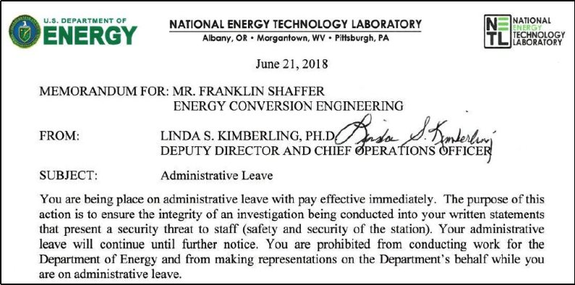
My sworn statement to the FBI that everything on this website is true
After Breault forced me to flee from the NETL, Trump’s criminals stole the equipment I’d purchased with $1.5 million dollars in funding from the USDOI Bureau of Safety and Environmental Enforcement and the USDOI Bureau of Ocean and Energy Management.
THE WORKPLACE MOBBING BY SENIOR FEDERAL EMPLOYEES
OF THE TRUMP ADMINISTRATION.
“Workplace mobbing is a malicious attempt to force a targeted individual out of the workplace through false accusations, humiliation, general harassment, emotional abuse, and terror. It is a “ganging up” on a targeted individual by the leaders of an organization, managers, and co-workers. Targeted individuals are usually high achievers who care about and speak about social injustices in their organization.
Injuries to the targeted individual include long term psychological damage, Post Traumatic Stress Disorder, chronic unemployment, social exclusion, and sometimes suicidal and homicidal reactions” (Groeblinghoff & Becker, 1996, p.277; Leymann, 1996, p.180). (Zapf & Leymann, 1996) (Vickers, 2006).
Here’s a link to an article about workplace mobbing by psychologist Dr. Dorothy Suskind: The Pain of Ostracization: The Bully’s Silent Weapon
“Workplace mobbing is a much more sophisticated way of doing someone in than murder, and in most countries, it has the advantage of being entirely legal”
Maureen Duffy, PhD and Len Sperry, MD PhD
THE WORKPLACE MOB WHO ATTACKED ME
 | NETL Director, former Secretary of Energy, Director of the US Army Chemical and Biological Combat Capabilities Development Command, Dr. Grace Bochenek.
 | NETL Chief Counsel Susan E. Malie, former City Solicitor of Pittsburgh, Director of the City of Pittsburgh Law Department, and Lead Counsel for the Pittsburgh Police.
 | NETL Law Director, former Navy JAG Commander, General Counsel of 60,000 combat-ready troops, corps leader for 800 attorneys, Mark Hunzeker.
 | NETL Chief Operating Officer (COO), former COO of the Western Area Power Administration’s 3,800 scientists and researchers in 15 states and 80 cities, “Dr.” Linda S. Kimberling.
 | Allen Lichvar, NETL Site Security Officer, former Security Officer for nuclear weapons at the USDOE Los Alamos National Laboratory
 | NETL Chief Financial Officer James E. Wilson
Here is a partial list of other members of the workplace mob
In honor and memory of my colleague and friend for 25 years, NETL Director Dr. Anthony V. Cugini. I believe he was murdered via weaponized workplace mobbing. I believe NETL Chief Counsel Susan E. Malie is responsible.
Why? Because she had the same thing done to me.
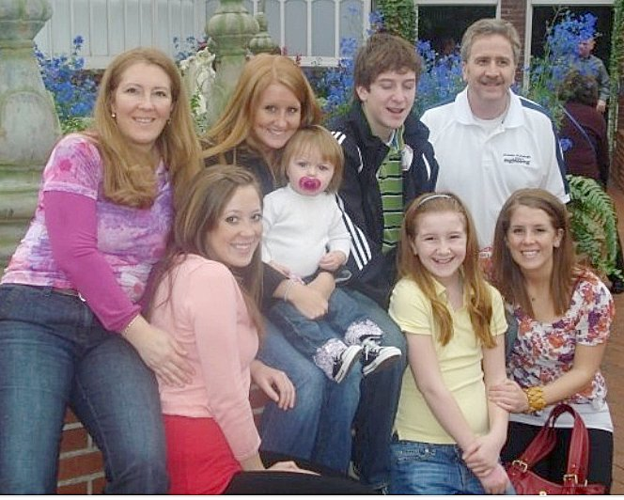 | 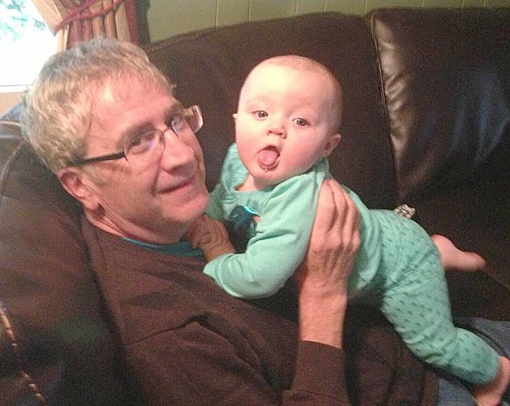
On January 8, 2014, NETL Director Dr. Anthony Vincent Cugini was found dead in a barren wooded are three miles from the NETL. Anthony was a devout Roman Catholic. On his way to the NETL each morning, he stopped by his Catholic church to pray for guidance in directing the NETL.
THE CHILLING EFFECT CREATED BY TRUMP CRIMINAL
NETL CHIEF COUNSEL SUSAN E. MALIE
In June of 2018, after I was forced to flee the NETL to protect my life -- even though I’d done nothing wrong – NETC Chief Counsel Susan E. Malie had my office sealed with bright yellow crime tape. She did that to create a “chilling effect” at the NETL to make sure no one ever dared to report the crimes by the Trump Administration.  chilling effect: using fear of retaliation to prevent the legitimate reporting of crimes | 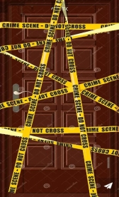
THE VIOLENT LYING TRUMP CRIMINALS
WHO ATTACKED ME IN RETALIATION FOR WORK FOR SOCIAL JUSTICE AND CIVIL RIGHTS IN PITTSBURGH
From around 1998 through 2006, I was an active member of the Thomas Merton Center in Pittsburgh (member of the TMC Board of Directors for a few years).
On September 21, 2001, ten days after Osama bin Laden attacked our country, I published online the original website for the Thomas Merton Center, ThomasMertonCenter.org I registered it in my name using my home address:
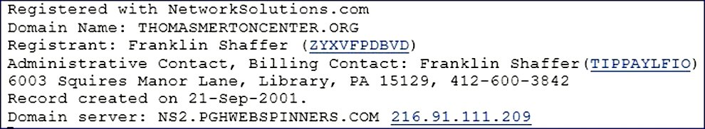
One of the reasons I created the website was that I knew how close Osama bin Laden came to having access to nuclear weapons. Click here for my report on being an eyewitness to the proliferation of nuclear weapons into Pakistan.
On August 7, 1998, seventy-one (71) days later, on orders from Osama bin Laden and Ayman al-Zawahiri, Al Quida suicide bombers blew up the US Embassy in Nairobi Kenya. More than 200 were killed and 5000 wounded.
They nearly killed my brother. He worked out of that US Embassy in Nairobi.
He was in Eldoret, Kenya, on that day.
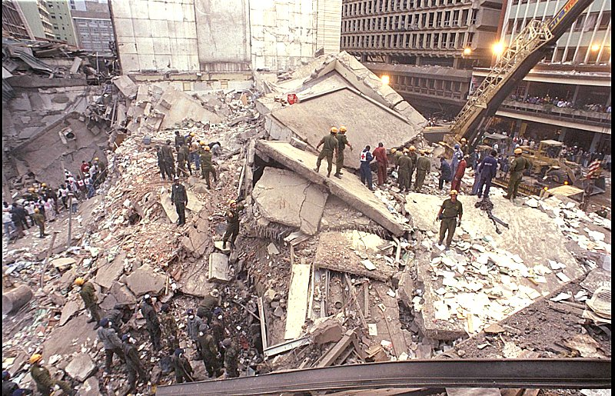  Rescuers search for survivors  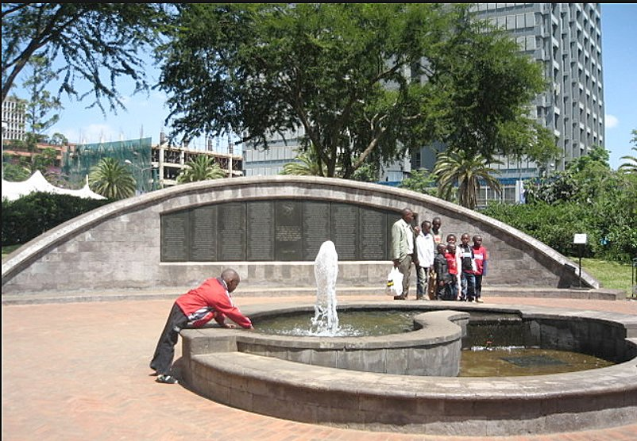  The August 7 Memorial in Nairobi | 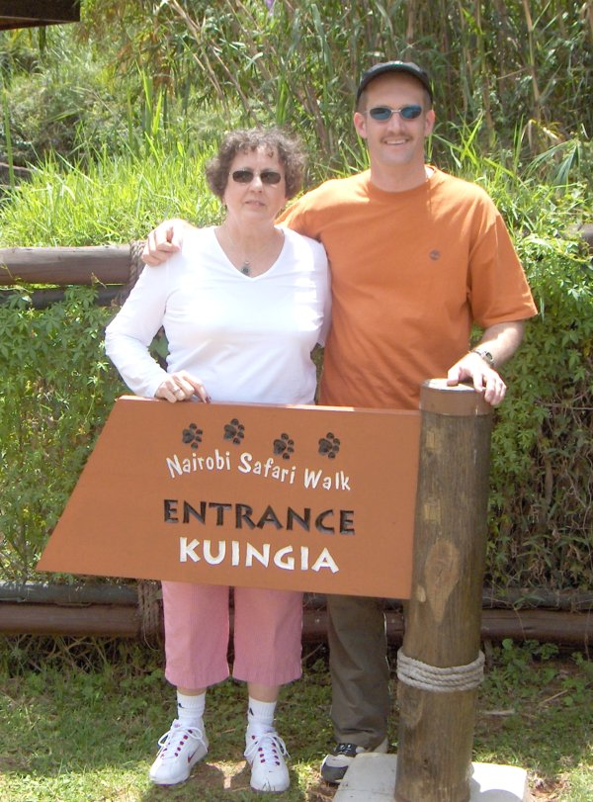  My mother and brother in Nairobi
THE VIOLENT LYING TRUMP CRIMINAL RONALD ARNONI
In 1999, I got involved with the Thomas Merton Center (TMC) in Pittsburgh to peacefully protest and file lawsuits against VLC Ronald Arnoni, Mayor of Brentwood, after three Brentwood police officers were acquitted for the murder of Jonny Gammage. In 1995, Jonny Gammage was driving a Jaguar luxury car owned by his cousin, Pittsburgh Steelers player Ray Seals through Brentwood, a suburb of Pittsburgh.
Gammage was committing no crimes, other than “DWB” in a luxury car through VLC Ronald Arnoni’s Brentwood. Arnoni’s police officers murdered Jonny Gammage in the same way George Floyd was murdered 25 years later – by positional asphyxiation -- in other words, suffocation by prolonged compression of his chest and neck. But in 1995 there were no cell phones with cameras to record the murder of Jonny Gammage.  The official autopsy and an additional autopsy by Dr. Cyril Wecht found that Gammage died ofpositional asphyxia.  I got involved with the TMC to peacefully protest and file lawsuits against VLC Ronald Arnoni. | Murder of George Floyd  by “positional asphyxiation”
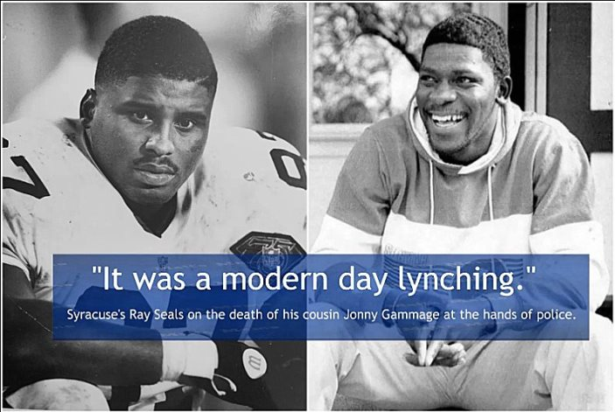
Click here or on the above photo to watch a four-minute documentary video
about the murder of Jonny Gammage.
If anyone knows how to contact Ray Seals, please ask him to view this page.
Jonny Gamage is gone but not forgotten.
Here’s a link to the original website I created for the Thomas Merton Center
VLC Ronald Arnoni was later accused of using police intimidation and bribes to get himself elected as the Magistrate of Bethel Park PA . His kangaroo court was ¼ mile from where I lived in my ZED house.
In 2017, Sergeant Kach returned to my home, alone – ALONE! He tried to enter my home. I was alone, so instead of letting Officer Kach enter my home (where no one could see what he was doing), I walked outside into the sunshine where neighbors could see us. Officer Kach then got his face in mine and started screaming at me and blowing spit in my face. He tried to steal $7500 from me under threat of arrest.
On January 18, 2019, VLC Magistrate Ronald Arnoni had police SWAT team surround and raid my house at 2786 Tischler Road in Bethel Park, PA. The search warrant signed by VLC Arnoni said they needed to check my gas furnace to make sure I was warm. They searched my entire house and evicted me into a freezing January night. That night I fled into Amish country Ohio to escape.
THE VIOLENT LYING TRUMP CRIMINAL
SUSAN E. MALIE, CHIEF COUNSEL OF THE NETL
As Chief Counsel for the NETL, the largest fossil fuel research lab in the world, Susan E. Malie has direct connections to NETL’s stakeholders, which includes British Petroleum. Chief Counsel Malie led the retaliation at the NETL for my role in causing British Petroleum to be fined $20.8 billion dollars.
From 1995 through 2006, VLC Susan E. Malie was an Assistant City Solicitor and then City Solicitor of Pittsburgh. My peaceful protests and lawsuits against her with the Thomas Merton Center were for her violations of civil rights and for condoning police brutality. I was a visible member of a plaintiff organization, the Thomas Merton Center, suing the City of Pittsburgh in the “People Against Police Violence” case in the US District Court for Western PA.
Susan E. Malie was the defendant for the City of Pittsburgh.
The Honorable US District Court Judge Joy Flowers Conti found that Malie engaged in unconstitutional violations of First Amendment rights, and that she intentionally delayed the court for three years to keep the unconstitutional regulations in place. Judge Conti ruled that the TMC, ACLU and NAACP were the “prevailing parties” and ordered Malie to pay the legal fees of the TMC, ACLU and NAACP.  The case was heavily covered by local and national news. It was a national embarrassment for Susan E. Malie and Hugh F. McGough – and rightly so. In 2006, near the end of the trial, the Mayor of Pittsburgh fired Malie for misconduct in what the Pittsburgh Post Gazette called “The Thursday Morning Massacre. | 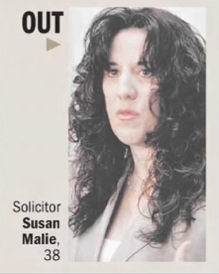  The federal Violent Lying Criminal NETL Chief Counsel Susan E. Malie
Malie later used political nepotism to become NETL Chief Counsel.
THE VIOLENT LYING CRIMINAL HUGH F. MCGOUGH
VLC Hugh F. McGough, along with the VLCs City Solicitor Susan E. Malie and VLC Mayor of Brentwood Ronald Arnoni were the subjects of my peaceful, lawful protests with the Thomas Merton Center.  VLC McGough later got himself elected as an Allegheny County common pleas court Judge. Somehow my divorce case ended up in his kangaroo court.  He and VLC Allegheny County Solicitor Luke C. Kelly exploited and manipulated my wife -- a religious scholar with a PhD in Religious Studies from Yale and the mother of two children with autism -- to use her as a weapon to steal my Zero Energy Design house, to fabricate false defamatory, inflammatory lies about me, and to steal my federal retirement pension. |   “A Disgrace to the Judiciary”
VLC McGough and the VLC Allegheny County Solicitor Luke C. Kelly forced me to sign away my federal retirement pension while they had me alone, without counsel, shackled to a metal table, under threat of five years imprisonment in the kangaroo court of VLC McGough.
I first encountered VLC McGough in the home of Dave and Rita Pollock on eve of the 2001 Mayoral election in Pittsburgh. Attorney Dave Pollock (an attorney I respect) was VLC McGough’s Campaign Finance Manager. I’d helped punk rocker 16-year-old Josh Pollock, son of Dave and Rita, run for Mayor of Pittsburgh.
I made a website for Josh’s Mayoral run. Here’s a copy of it:
JoshforMayor.org
The only real contenders for Mayor were Tom Murphy and Bob O’Conner. But Josh got enough votes to cause Bob O’Connor to lose to Tom Murphy. That was not Josh’s intention.
The VLC Assistant City Solicitor Susan E. Malie and VLC McGough supported Bob O’Connor. When O’Connor lost, they lost opportunities for more power and influence in what would have been the O’Connor Mayoral Administration.
When O’Connor did win the next Mayoral election, he made VLC Malie the City Solicitor of Pittsburgh and VLC McGough became the Solicitor for the Pittsburgh Police Citizen’s Review Board. Both Malie and McGough were targets of my legal, peaceful protests and lawsuits with the Thomas Merton Center.
My sworn statement that everything on this website is true
ATTACKS BY THE VIOLENT LYING CRIMINAL
ALLEGHENY COUNTY SOLICITOR LUKE C. KELLY
The crimes done to me and my family by VLC Luke C. Kelly are so numerous and so profoundly cruel that it is difficult for me to write about them. He tried to cause my death several times and make it appear to be a death by natural causes. VLC Kelly committed those crimes against me so my wife, who was his client, would inherit the royalties of the technology I invented and patented (US 8,391,552). Independent experts reviewed the technology of 8,391,552 and found it to be “huge breakthrough” and “something the petrochemical industry had sought for 50 years…”
His most heinous attacks were in the form of hate crimes. Click here for a report about his hate crimes against me. I just submitted it to the FBI.
I do not know if my wife was complicit. That is something for the FBI to determine. In any case, I believe that one should became the inheritor of the royalties of my US Patent 8,391,552, he would have killed her too and would have made it appear to be by natural causes. Then he and his employer, Republican donor Troy Halo, would have received the royalties of 8,391,552.
His first attempt to kill me and make it appear to be by natural causes was in September of 2018. He sat beside me in Lemonheads Bar & Grill in Bethel Park, PA, and passed himself off as a major drug dealer. He is heavily tattooed. His entire forearms are covered with tattoos. He left. About 10 minutes later I left. I fell on the floor. I could not feel or move my legs. I believe he drugged me with some kind of paralytic. If I hadn’t lived, it would appear to be a self-inflicted drug overdose.
Allegheny County Solicitor Luke C. Kelly and the federal employees of the NETL had an application for the Federal Medical Leave Act (FLMA) written for me by Dr. Carol Kunkle-Miller, a PhD licensed psychologist in the state of Pennsylvania. She calls herself a “Life Coach.” I started seeing her in April of 2018 to have her coach me on how to cope in a healthy way with the attacks I was being subjected to at the USDOE NETL by senior federal employees of the Trump Administration, including former Secretary of Energy Grace Bochenek.
In Section 4 of the FMLA, shown below, Dr. Kunkle-Miller gives the diagnosis of “Major Depression, Recurrent, without psychosis.”
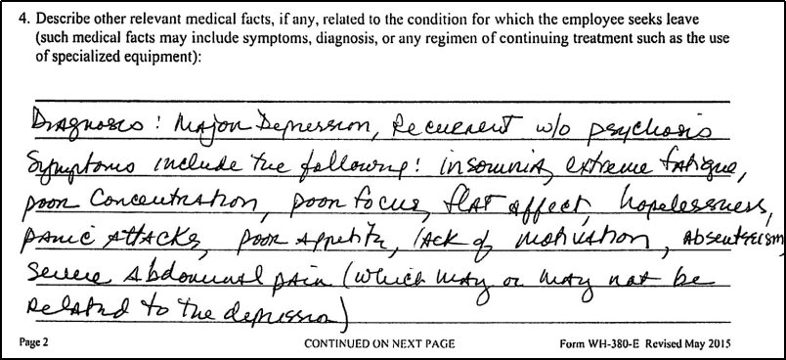
In Section 7 of the FMLA, Dr. Kunkle-Miller writes that the symptoms of Major Depression “can be easily triggered…”
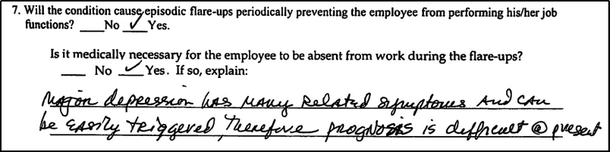
Of course, the most dangerous symptom of Major Depression is suicide. So Allegheny County Solicitor Luke C. Kelly triggered me in the most heinous ways, including hate crimes.
I believe the VLC’s instigated my divorce. The only thing we needed to do was sell our house and split the profits/losses. That should have taken less than a year. But VLC Kelly and VLC McGough dragged out the divorce for more than eight years. I believe that VLC Malie was also involved.  The divorce consisted of nothing but VLC Kelly submitting Motions that were derogatory inflammatory lies about me. Every attorney I paid to represent me betrayed me and worked with the VLC’s to steal my federal retirement savings. | The Violent Lying Criminal Snake  Allegheny County Solicitor Luke C. Kelly.
Then VLC McGough would sign Orders written by VLC Kelly. Their Orders stole my Zero Energy Design (ZED) house from me. They stole from me almost everything I earned in 32 years of federal service to our country.
VLC Kelly stole $55,000 of my federal TSP retirement savings and put it in his sleazy Violent Lying Criminal pocket.
Later, to try to have me killed, he had me thrown in the Licking County Jail in Newark Ohio. To incite the inmates to rape, castrate and kill me – he had the inmates told that I was a “chomo.” Chomo is prison slang for a child molester. I believe this is a hate crime.
He began his fabrication of false charges and attempts to cause my death in September of 2018. On October 29, 2018, two days after the worst murder of Jewish people in US history: the massacre at the Tree of Life or L’Simcha synagogue in Pittsburgh, he escalated his attacks on me. He “triggered” me in the most hateful ways. He knew that in the late 1990’s I was married to a German Jew who lost family in the holocaust. He knew we lived near the Tree of Life. He knew we attended the Tree of Life. I believe his actions constitute hate crimes.
 | 

My sworn statement that everything on this website is true
This is my family that the Violent Lying Criminals (VLC) destroyed.
  The VLC’s Luke C. Kelly, Ronald Arnoni and Hugh F. McGough  caused the death of two of my doggies. |   The VLC’s Susan E. Malie, Ronald Arnoni, Luke C. Kelly and Hugh F. McGough have no shame.
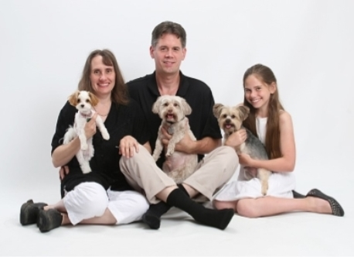
This is our Zero Energy Design (ZED) house that the VLC Magistrate Ronald Arnoni had a SWAT team raid without cause, so VLC Allegheny County Solicitor Luke C. Kelly and VLC common pleas Judge Hugh F. McGough could steal it from me. Then they used it to steal my federal retirement savings. After the SWAT team raid, someone trashed my house and left the front door wide open.
  My solar “Zero Energy Design” house.  I spent three years remodeling and improving it. |   I had to get to the top of a 40 foot  ladder to clean the windows on our solarium.
THE VIOLENT LYING CRIMINAL BTK KILLERS
They effectively kidnapped my wife – a religious scholar with a PhD in Religious Studies from Yale and the mother of two children with autism -- using a Bind-Torture-Kill kit far more dangerous than that used by the evil BTK killer. Their BTK kit was made up of lies by the Trump Administration, by Pittsburgh Police, by Pittsburgh lawyers and by a Pittsburgh Magistrate. | 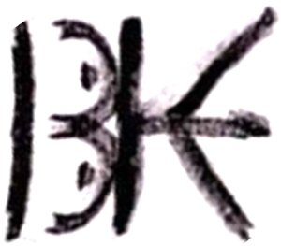
THE PITTSBURGH SYMBIONESE LIAR ARMY
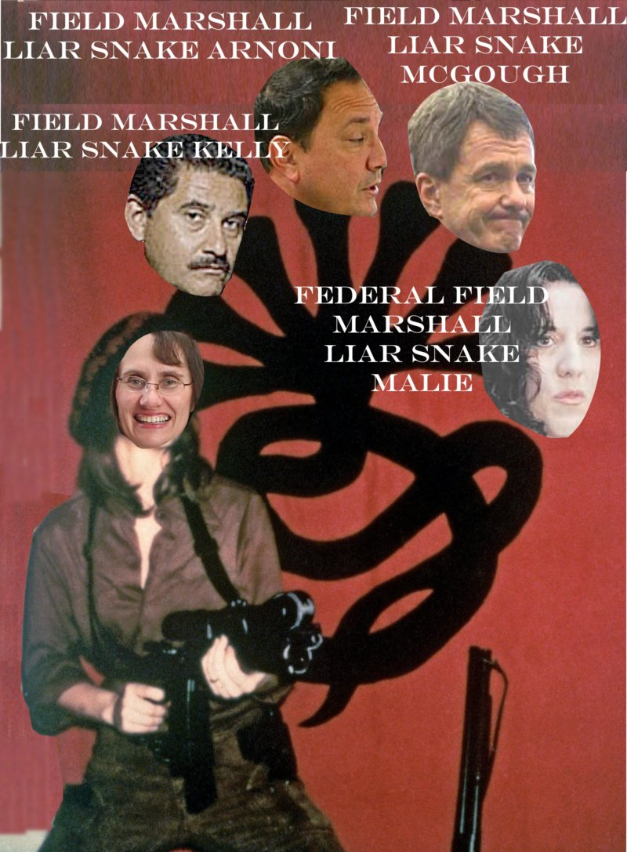
Patty Hearst was kidnapped and brainwashed by the Symbionese Liberation Army because her family had assets of $20 billion dollars.
I caused an oil company to lose $20.8 billion dollars.
Her sentence was commuted by my hero President Jimmy Carter.
She was pardoned by President Clinton.
Because of the crimes done to me by the VLC’s, I’ve had to eat out of garbage dumpsters to survive, while the VLC Luke C. Kelly was dining at four-star restaurants on my federal retirement savings.  My pal “Radioman” taught me how to “dumpster dive.” He’s called Radioman because he believes he has a radio chip in his head.  Radioman lives in a garbage dumpster. It’s the only place he can get some peace and quiet. The ferric metal of his home, a garbage dumpster, blocks all radio signals… |  | 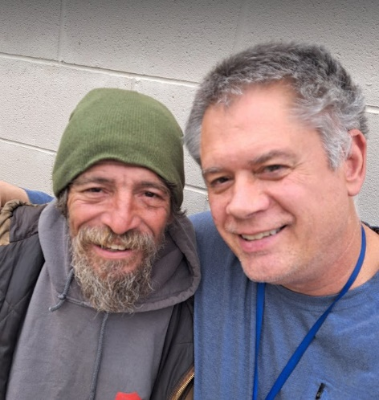  My pal and teacher, Radioman
I respectfully ask you DOE Secretary Attorney Granholm, Attorney General Garland, Assistant Attorney General Clark, and Director Shalandra H. Baker, to investigate and prosecute the criminals who destroyed my life, my DOE career, and my family.
I respectfully ask to be returned to the federal service of our country at the US Department of Energy.
I have more information about my work with the DOE and my civil rights work on my website: http://FDShaffer.net My website is also a formal sworn crime report to the FBI.
More information is forthcoming…
Respectfully, I am,
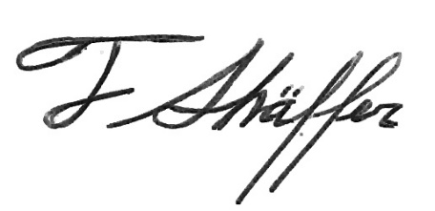
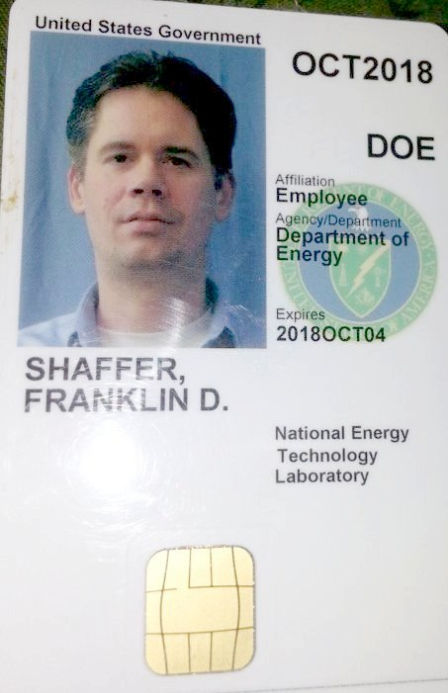
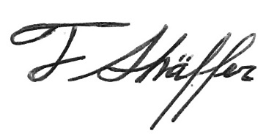
I helped The Tree of Life Synagogue in Pittsburgh “get papers” under false pretenses for two Russian Jewish scientists who were being persecuted in Moscow. Those Russian Jewish scientists are Dr. Marina Kameneva and her husband the late Dr. Boris Kushner. Dr. Kameneva needed documentation showing that she was working in a scientific laboratory in the US. So I had this photo taken of her in my US government laboratory. I had everyone wear laser safety goggles so Dr. Kameneva would not be easily recognized if the photo were displayed publicly. But when she showed it to an INS official, the INS official would easily recognize Dr. Kameneva as a scientist wearing laser safety goggles in a laboratory of the United States Department of Energy.
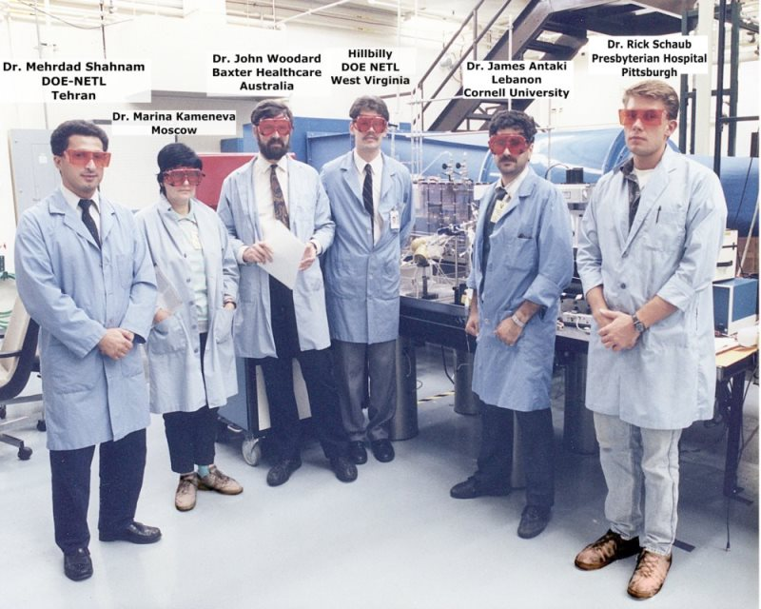
I could do this only because I had the full behind-the-scenes support of the Honorable Attorney Congressman Harley O. Staggers Jr.
Dr. Kameneva earned her PhD in Mechanical Engineering from the School of Mathematics and Mechanics at Moscow State University (former Soviet Union) and subsequently worked at the Research Institute of Mechanics, Moscow State University.
Today Dr. Kameneva is the Director of the Artificial Blood Research Laboratory at the McGowan Institute for Regenerative Medicine in Pittsburgh. She is saving American lives.
Dr. Boris Kushner earned his Ph.D. in Mathematics from Moscow State University in 1966 and worked at the Computing Center of the Russian Academy of Science for 23 years. His book “ Lectures on Constructive Mathematical Analysis ”was published in Russia and the US by the American Mathematical Society. For 27 years, he taught mathematics at the University of Pittsburgh, Johnstown. He retired as a Professor Emeritus in 2017.
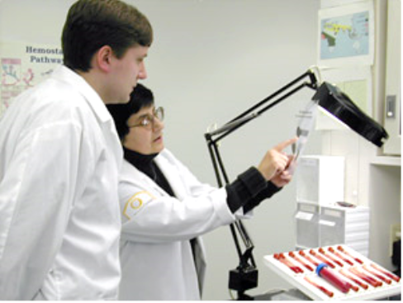 | 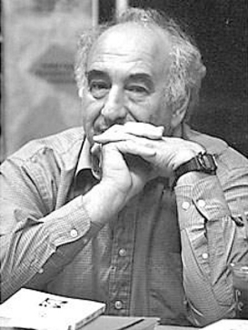
Here’s one of the publications I co-authored with Dr. Kamaneva:
Development of an Axial Blood Flow Pump
K.C. Butler, T.R. Maher, H.S. Borovetz, R.L. Kormos, J.F. Antaki, M. Kamaneva, B.P. Griffith, T. Zerbe, F D Shaffer, Journal of the. American Society for Artificial Internal Organs, 38(3): M296-300. 1992, DOI: 10.1097/00002480-199207000-00041J.
ABOUT MY FEDERAL SERVICE FOR MY COUNTRY (Return to Homepage)

This website is protected by The Digital Millennium Copyright Act
If you want to use any of the content of this website, please contact me for permission.
Also, if anyone has suggestions on how I can improve this website, please let me know!

